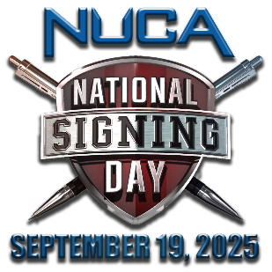
Hello [First Name],

It’s [Your Name] from [Your Company Name]. When [Company Name] became National Utility Contractors Association (NUCA) members we did it as an investment in growth and success for the company and team. It’s been a great decision for us, that’s really paying dividends! NUCA is the only national trade association dedicated solely to addressing the issues and needs of companies like ours in the utility construction and excavation industries, and right now, during NUCA’s National Signing Day new member campaign, it’s the perfect time to make that same investment for [Company Name]!
The value that NUCA and [Your Chapter’s Name (if any)] is delivering for your membership investment has never been higher and the membership offer has never been better. Join now and you’ll receive company membership for you and your whole team through the end of 2026, at the 2025 price. You’d be getting nearly 16 months of membership for the price of 12, and it’s at this year’s rate!
When you join NUCA you’ll enjoy membership value and benefits that help advance your business and save you money on your bottom line. Here’s a link to NUCA's National Membership Guide to look over. This guide outlines the national member benefits and programs that accompany your membership, including:
- Safety education, certification, and training programs for your employees and trainers
- National advocacy in Washington, D.C. on issues impacting your business
- Damage Prevention & Claims Avoidance Program & HR consulting & resources
- Networking opportunities to help forge new business relationships at NUCA events
- Opportunities for business cost reductions and potential dividends through member-only insurance programs: NUCA Advantage, NUCA Choice, and NUCA Assurance
- Business listing & access to our online Member Directory, NUCA Career Center, industry publications, and much more.

[Add a short paragraph here giving an example of how your NUCA membership has paid off for you, your company, or team]

The adage that there’s strength in numbers is true. As NUCA members, utility and excavation contractors, suppliers, and manufacturers form a united voice for our companies and the vital infrastructure work we do. Together we’re accomplishing things we can't accomplish alone, for our businesses, our industry, and our communities. I hope you’ll join us, get your team involved, and make #NUCAStrongerTogether this National Signing Day! [Attach Letter of Intent, application form &/or link to your online application]

Let’s talk soon so I can answer any questions you might have. Please don’t hesitate to contact me directly at [Insert Phone #] or [Insert Email].

Best regards,

RED = [insert recipient personalization]
GREEN = [insert your/your chapter information]

