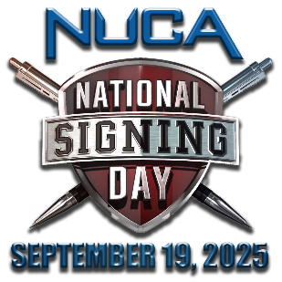
Hello [First Name],

It’s [Your Name] from [Your Chapter Name]. Becoming a National Utility Contractors Association (NUCA) member is an investment in growth and success for member companies that pays dividends! NUCA is the only national trade association that’s dedicated solely to the issues and needs of the utility construction and excavation industries and contractors in the U.S.A., and right now, during NUCA’s National Signing Day new member campaign, is the time to make that investment for [Company Name]!
The value that NUCA and [Your Chapter Name] is delivering for your membership investment has never been higher and our membership offer has never been better. Join now and you’ll receive company membership for you and your whole team through the end of 2026, at the 2025 price. That’s nearly 16 months of membership for the price of 12, and it’s at this year’s rate!
When you join NUCA you’ll enjoy membership value and benefits at both the national and chapter levels of the association. Here’s a link to NUCA's National Membership Guide for your review. This guide outlines the national member benefits and programs that accompany your membership, including:
- Safety education, certification, and training programs for your employees and trainers
- National advocacy in Washington, D.C. on issues impacting your business
- Damage Prevention & Claims Avoidance Program & HR consulting & resources
- Networking opportunities to help forge new business relationships at NUCA events
- Opportunities for business cost reductions and potential dividends through member-only insurance programs: NUCA Advantage, NUCA Choice, and NUCA Assurance
- Business listing & access to our online Member Directory, NUCA Career Center, industry publications, and much more.

[Add a paragraph here about your Chapter, what it offers and how it represents & benefits its’ members]

The adage that there’s strength in numbers is true. As NUCA members, utility and excavation contractors, suppliers, and manufacturers form a united voice for the vital infrastructure work we do both nationally and here in [Insert Chapter Area]. Together we accomplish things we can't accomplish alone, for our businesses, our industry, and our communities. I hope you’ll join us, get your team involved, and make #NUCAStrongerTogether this National Signing Day! [Attach Letter of Intent, application form &/or link to your online application]

Let’s find a time to talk so I can answer any questions you might have. Please don’t hesitate to contact me directly at [Insert Phone #] or [Insert Email].

Best regards,

RED = [insert recipient personalization]
GREEN = [insert your/your chapter information]

